# Pets

You need to add 20 things to this document. (Make sure to number them just as I did in the example.) It may be helpful to copy and paste this list and then fill it in as you go along. All image names must start with your location, e.g yellowstone_sunset.jpg unless you are using a link from the internet.

## Brul

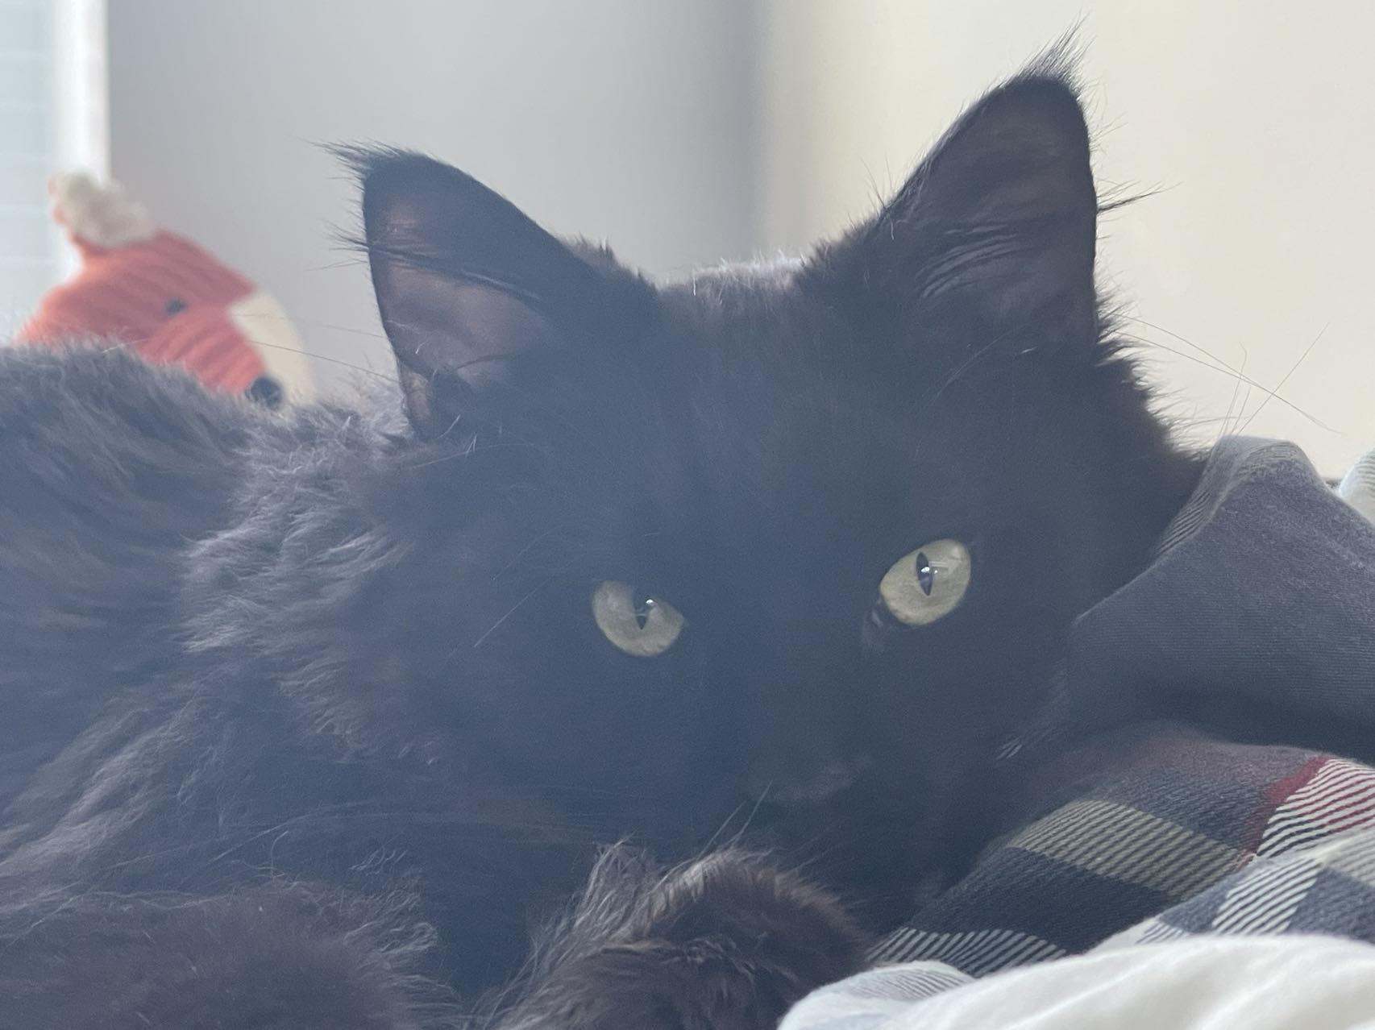

1. Brul.jpg
2. Brown fuzzy cat
3. Brul is a 2yr old Maine coon cat. She prefers to spend his days lying in the bed. She enjoys watching outside from the window as long as there are no loud noises and bugs outside.
4. Brul loves walks on the beach and taking sun naps on a warm summer day. Brul is a playful cat but enjoys having slow, relaxed days at the same time. She hates grooming and bathing.
5. **Photo Gallery – (Just write Photo Gallery)**
6. Brul1.jpg
7. Brul lying on the climbing frame in the morning
8. Brul2.jpg
9. Brul lying on the climbing frame in the morning
10. Brul3.jpg
11. Brul lying on the climbing frame at night
12. Brul4.jpg
13. Brul lying in a box
14. **Likes – (Just write Likes)**
15. Eating
16. Sleeping
17. Scratches
18. Yimin Li + [Paul Lellouche](mailto:pllch@umich.edu)+ Brann Khattiyanont

## Bacon Q Dog

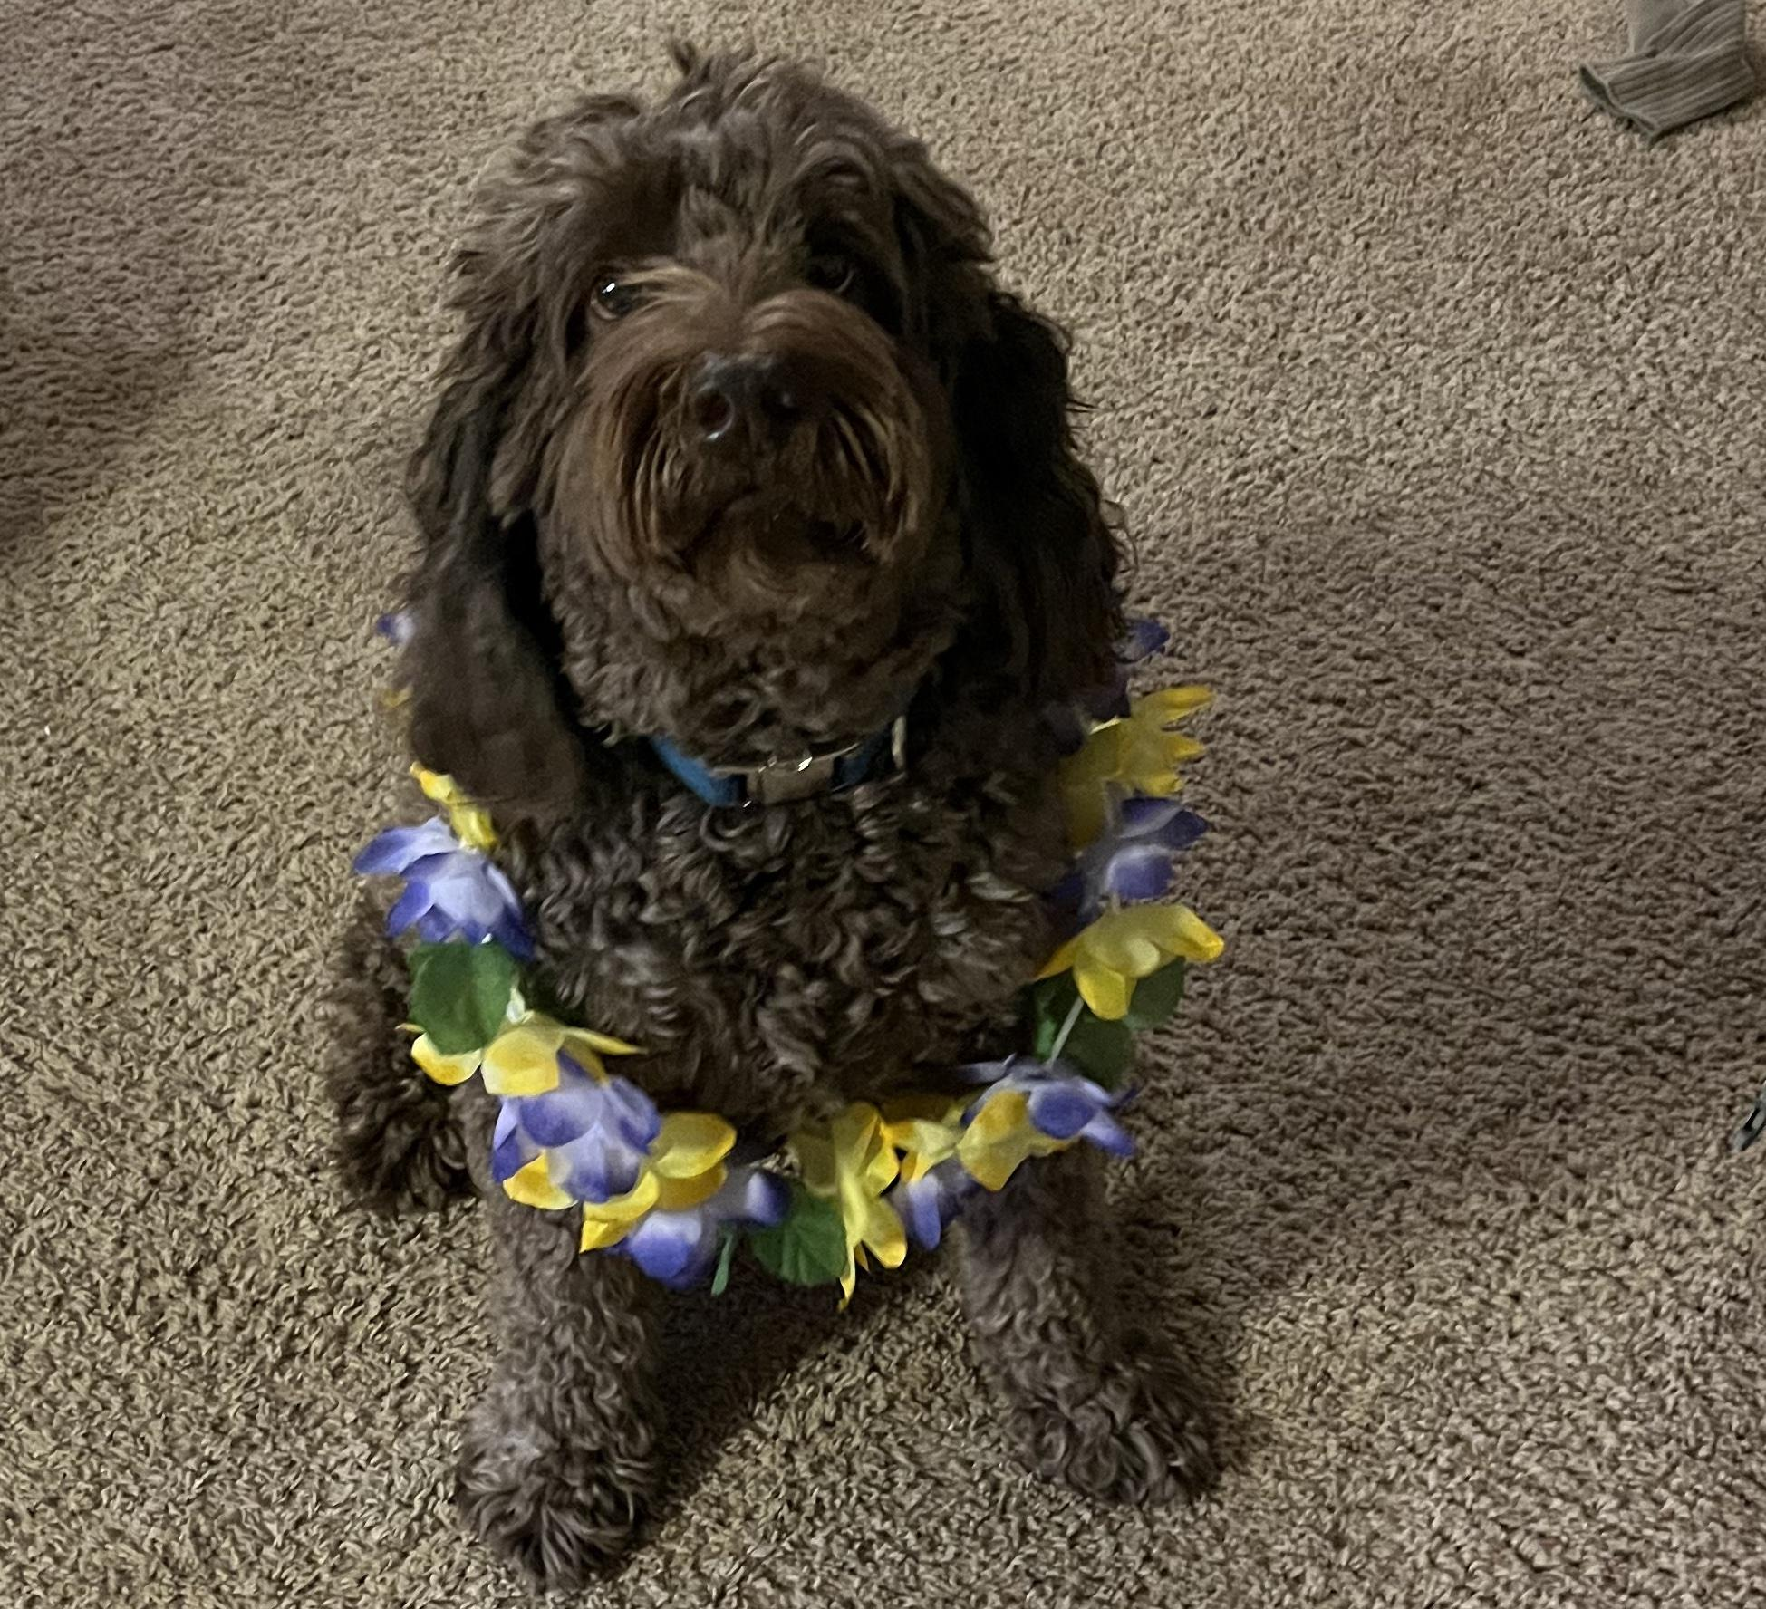

1. bacon.jpg
2. Brown labradoodle wearing colorful lei
3. Bacon Q. Dog is a 9yr old labradoodle. He prefers to spend his days lounging among the three different beds/couches that his family has gifted him. He enjoys a walk or two around the neighborhood, as long as he can pretend that he doesn't see any of the other animals to avoid the embarrassment of not wanting to admit he has no wolf-like skills in chasing them.
4. At night just as the rest of the family is ready to relax, Bacon suddenly wants to release all of his energy. He will place his toys on a mini couch and frantically drag the couch around, giving his toys "a ride." There is also a lot of rolling. Lots and lots of rolling.
5. **Photo Gallery**
6. bacon_bandana.JPG
7. Brown labradoodle wearing an orange bandana
8. bacon_graduation.JPG
9. Small labradoodle puppy wearing a graduation cap and gown.
10. bacon_agility.mov
11. Girl and dog demonstrating a sit and stay procedure
12. bacon_halloween.JPG
13. Brown labradoodle wearing a pirate costume
14. **Likes**
15. Belly rubs
16. Playing tug-of-war
17. Sneaking onto the couch
18. Colleen van Lent